DM-G60 Drone Motor
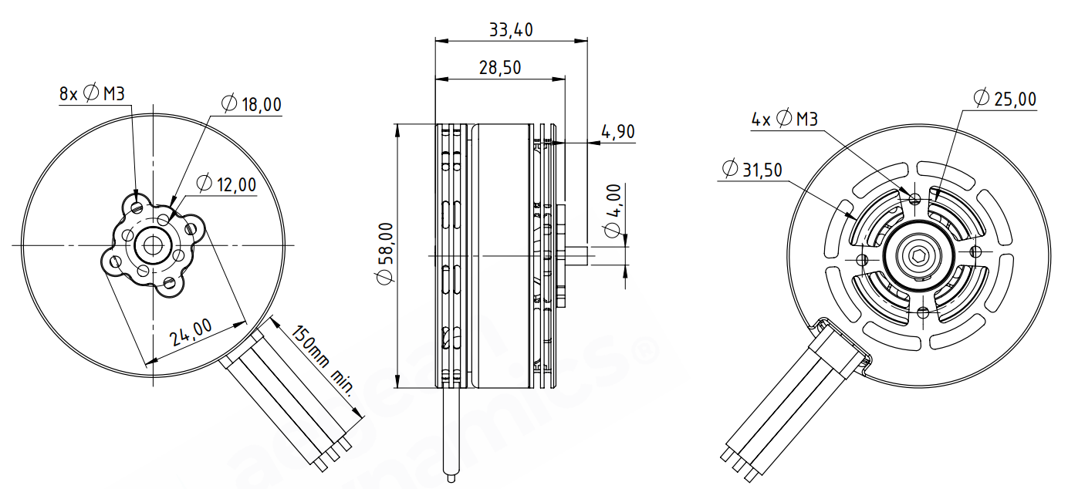
Basic Motor Parameters
Throttle | % | 60
Max. Thrust | kg | 5.2
Recommended Takeoff Weight | kg | 2-2.5
Torque | Nm | 0.52
KV Rating | rpm/V | 300
Bus Voltage | S | 4-6 S
Max. Efficiency | % | 82
Operating Current | A | 11
Rated Speed | rpm | 3500
Propeller Force Efficiency | g/W | 8.8
Electrical Parameters
Number of Phases |  | 3
Number of Poles |  | 28
Terminal Resistance Phase to Phase (±%10) | mΩ | 65
Terminal Inductance Phase to Phase (±%30) | mH | 45
Thermal Data
Ambient Temperature | °C | -40...+85
Max. Winding Temperature | °C | +155
Physical Parameters
Outer Diameter | mm | 58
Shaft Diameter | mm | 4
Max. Lenght | mm | 33,4
Weight | gr | 195
Motor Connection
U | BLACK CABLE
V | BLACK CABLE
W | BLACK CABLE
Sensor Connection
N/A | N/A
Connector Articles
Power | N/A
Signal | N/A
Propeller Info (Recommended)
Diameter | 22.2”
Pitch | 7.2”

